**NAME – RAKSHIT TIWARI**

**ROLL NUMBER – 160123032**

**LAB 03**

Q1)

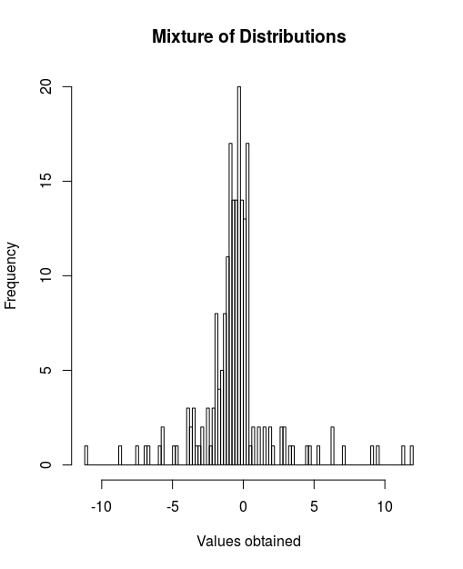

The data for random samples can be viewed using the file **data.txt** inside the folder.

Q2)

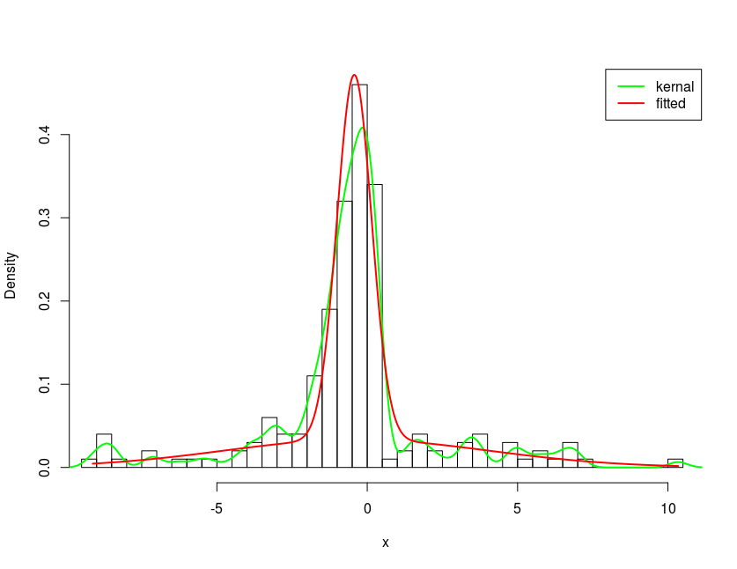

Our own code for E-M algorithm fits better here in this given data set. Red curve in the above picture depicts the same

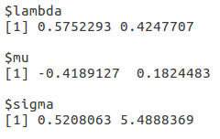

Also, following are the values that we obtained when we used the normalixEM function in R to apply EM algorithm to our dataset.